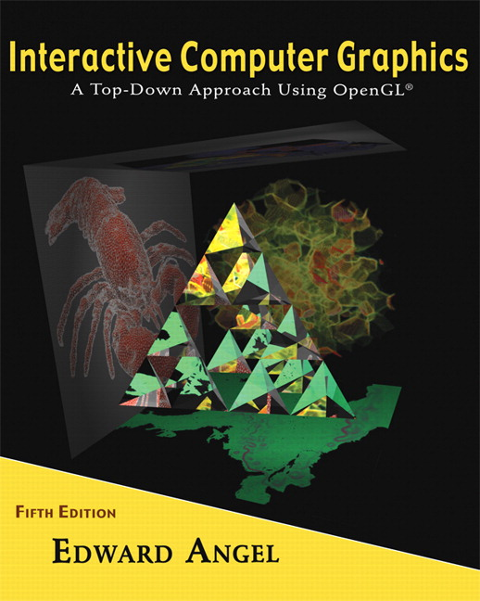

Name: ______________________ Terminal # ____
Programming Assignment 2
(100 points)

The Programming Assignment is to be turned in the first ten minutes of the due date class as:

Hardcopy (with your terminal #!)
Source Code and Screenshots that shows that your Visual Studio 2010 “Programming Assignment 2” PROJECT compiles and runs!

Electronic: Submit the Visual Studio2010 “Programming Assignment 2” zipped PROJECT to BB so you can run it in 200 PGH!

Origami JURASIC PARK - Summer 2013 Modeling Instructions

1. The glutCreateWindow OpenGL call will take as parameter “YourLastName JURASIC PARK Version 2”.
2. Start with the “Origami JURASIC PARK Summer 2013.doc” that you have created in Programming Assignment 1 and call the file JURASICPARK.c. Please make sure that the colors schema is observed.

3. Create a menu – Viewing and submenu and keyboard (f, b, r, l, t, u, i) that allows that you to view the JURASIC PARK from (F1 is the Help Key):

- front;
- back;
- right side;
- left side;
- top;
- under;
- isometric.

Get a screenshot of the “YourLastName JURASIC PARK Version 2” window for each view.

4. Add the fly through navigation to the JURASIC PARK from (see Homework 3).

